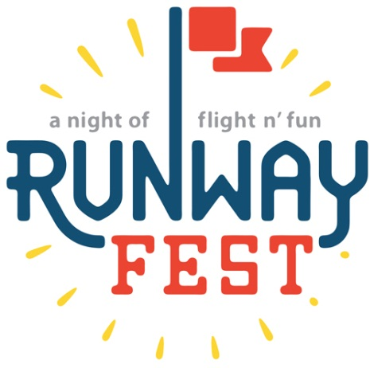

Runway Fest 2019

Dear Potential Sponsor:

The Dayton-Wright Brothers Airport will host its 8th Annual Runway Fest on August 9, 2019. Runway Fest continues to be an overwhelming success and a great family event with something for everyone to enjoy. In 2018 this event was attended by over 3,500 visitors. The festival includes great food, live music, fantastic entertainment and we close the night with top-notch fireworks. This FREE event encompasses fun for the whole family with a live band, inflatables for the kids, static displays, and much more.

We hope you will take advantage of this great opportunity to showcase your organization’s involvement with the community and become a sponsor. To get an idea of what you will find at Runway Fest, please visit us at www.flydayton.com and click on, about DAY and select events; there you will see some pictures of the event.

We look forward to making you part of this wonderful event and hope you are able to join us for this one of a kind community event. For information regarding the sponsorship, please see the attached forms. If you have any questions, please feel free to contact myself, Zeana Kitchens (937) 454-8217 or Zkitchens@flydayton.com you can also reach out to Yolanda Sanders at (937) 454-8219 or YSanders@flydayton.com.

Runway Fest 2019 Sponsorship Levels

Platinum Sponsor
$2,000
- Recognition on media news releases
- Name/logo on all printed materials
- Logo on t-shirts
- Large logo on main banner
- Recognition at event via PA announcements
- 7 T-shirts for your staff
- Display Table in the Expo area (no sales)
- 4 VIP parking passes

Gold Sponsor
$1,000
- Recognition on media news releases
- Logo on t-shirts
- Medium logo on main banner
- Recognition at event via PA announcements
- 5 t-shirts for your staff
- Display Table in the Expo area (no sales)
- 2 VIP parking passes

Silver Sponsor
$700
- Logo on t-shirts
- Small logo on main banner
- Recognition at event via PA announcements
- 3 t-shirts for your staff
- Table for display in the Expo area (no sales)

Bronze Sponsor
$500
- Name on t-shirts
- 2 t-shirts for your staff
- Table for display in the Expo area (no sales)
Runway Fest 2019
Sponsorship Response Form

August 9, 2019 at Dayton-Wright Brothers Airport

YES! WE WILL PARTICIPATE AS SPONSOR:

☐ Platinum Sponsor $2,000*
☐ Gold Sponsor $1,000*
☐ Silver Sponsor $700*
☐ Bronze Sponsor $500

☐ In-Kind Sponsor Donation ___________________________________
(Any non-monetary donation such as door prizes, advertising, products, etc.)

Please list your Name or Business as you want it to appear:
________________________________________________________________
Type: ☐Organization ☐Group ☐Business ☐Individual
Contact Person:
Address: __________________________________________________________
City: ____________________ State:___________ Zip: __________
Phone: (937) 520-9576
Email Address: _____________________________________________________

Authorized Signature: ________________________________________________
_____________________________________________________________________
Website, Twitter, Facebook, Instagram, etc.

Please make checks payable to: DACC EPI Foundation for Runway Fest

Please return this form with sponsorship check to:
Yolanda Sanders
Dayton Int’l Airport
3600 Terminal Drive, Ste. 300
Vandalia, OH 45377

*NOTE: Please e-mail a high-resolution file of your company’s logo to ysanders@flydayton.com by June 28, 2019.

