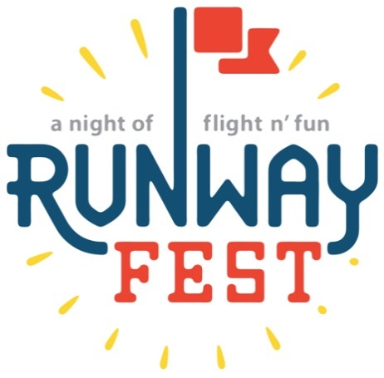

Runway Fest 2018

Dear Potential Vendor:

Dayton-Wright Brothers Airport is hosting its 7th Annual Runway Fest on August 10, 2018. Runway Fest continues to be an overwhelming success. In 2017 this event was attended by over 3,500 visitors. The festival includes great food, fantastic entertainment and top-notch fireworks. This FREE event encompasses fun for the whole family with a live band, inflatables for the kids, top-notch fireworks, and much more.

Runway Fest is promoted as a community-wide event and advertisements and articles will be placed in local newspapers. Flyers will be placed throughout the local area in stores and businesses. There will also be publicity through electronic billboards, strategically located banners, participating organization websites, and social media. #RunwayFest2018.

We hope you will be able to join us for this one of a kind free community event. For information regarding the vendor application process, please see the attached forms. Thank you so much for your consideration and we look forward to seeing you at Dayton-Wright Brothers Airport for the 7th Annual Runway Fest! If you have any questions, please feel free to contact us.

Yolanda Sanders YSanders@flydayton.com 937-454-8219
Brandon Ellis BEllis@flydayton.com 937-454-8230

Sincerely,

Runway Fest Committee
Runway Fest 2018

The 7th Annual Runway Fest will be held at Dayton-Wright Brothers Airport on Friday, August 10, 2018 from 6:00 PM – 10:00 PM.

If you are interested in taking part in this event as a vendor or expo participant, please read the following information, complete the enclosed application, and return it along with proof of insurance to:
Yolanda Sanders
3600 Terminal Dr.
Dayton, Ohio 45377

DEADLINE: Deadline for applications is July 6, 2018
(No refunds for cancellations will be given after deadline date)

SET-UP: Friday, August 10, 1:00 PM- 4:00 PM
-NO ELECTRIC WILL BE PROVIDED- YOU WILL NEED TO SUPPLY YOUR OWN GENERATOR IF NEEDED.

FESTIVAL HOURS: Friday, August 10, 2018 6:00 PM – 10:00 PM
-NO vehicle movement is permitted during the event.

SPACE: Vendor spaces are outdoors and the standard size of each space is 15’ x 15’.
Expo spaces are indoors and the size is 6’ x 4’.
Special accommodations can be made, with advance written approvals.

COSTS: $0 – Expo Participants (no sales allowed at the expo booths)
$50 – Craft and other non-food vendors
$150 – Food Vendors
Or Join our Sponsor Levels from $250- $1,500 and the Vendor fee will be waived.
(Invoices for payment of fees will be sent to approved Vendors)

TEAR DOWN: Friday, August 10, 10:00 PM- 11:30 PM, you are not able to move vehicles during the event or drive out of the airport gates until after the fireworks are completed and you have been cleared to leave. Vendors are responsible for cleaning up, including spills on the ramp and trash removal after the event.

SOCIAL MEDIA: We’d love for the vendors to help us generate a buzz around the event in addition to our own marketing campaign. We’d like each vendor to post at least 5 different posts on their social media accounts (Facebook, Twitter, Instagram or Snapchat) during the week of the event and at least 2 posts during the event. Using the hashtag #RunwayFest2018.

NOTICE: Vendors are responsible for erecting their own booth or tent, displays, equipment, etc. A limited number of tables and chairs are available to expo participants on a first-come, first-serve basis. Vendor booths and equipment must remain set up for the entire operating time of the festival. The Runway Fest committee reserves the right to remove any vendor, exhibitor, or exhibit or any part thereof whose conduct or content is not deemed acceptable. No refunds for cancellations after July, 6 2018. Runway Fest is primarily an outdoor event and no alternative rain date or site is planned. Vendors should come prepared for weather, however the event maybe cancelled due to extreme weather such as severe thunderstorms with lightening or tornado watches or warnings.

INFORMATION : Yolanda Sanders 937-454-8219
Email : ysanders@flydayton.com
Runway Fest 2018 Vendor and Expo Application

Friday, August 10, 2018 / 6:00 PM – 10:00 PM

_____________________________________________ __________________________
Vendor Name Event On-Site Contact Name
Vendor Type: ☐Organization ☐Group ☐Business ☐Individual

________________________________________________________________________
Street Address, City, State, Zip

____________________ ______________________ __________________________
Primary Telephone On-Site Contact Telephone Email

________________________________________________________________________
Website, Twitter, Facebook, Instagram, etc.

Participation Level
☐Expo Participant (no sales) ☐$50 Craft and other vendors ☐$150 – Food Vendors
☐$250 Bronze Sponsor ☐$500 Silver Sponsor ☐$1,000 Gold Sponsor
☐$1,500Platinum Sponsor

________________________________________________________________________
Description of Craft / Display Items:

________________________________________________________________________
________________________________________________________________________
________________________________________________________________________
Food Menu and Costs for the Event

Please return your completed application to:
ysanders@flydayton.com or
Yolanda Sanders
3600 Terminal Dr.
Dayton, OH 45377

*DO NOT SEND PAYMENT WITH APPLICATION*

HOLD HARMLESS AGREEMENT
Exhibitor releases and holds harmless the facility that is being used, sponsors, owners, managers, agents, servants and employees of all participating organizations from all responsibility, personal liability, loss or damage, theft, fire, loss of life, personal injury and/or damage to property that may arise or occur to exhibitor, his employees, agents, servants, associates, goods, property or the public and from any conditions whatsoever that may arise while the premises are in use, during show hours or when closed after show hours. We reserve the right to remove exhibitor and exhibits whose conduct or content is not acceptable. Misrepresentation on the part of the exhibitor in any form will result in cancellation of space and total loss of fee. Entry constitutes an agreement that the exhibitor and his representatives take no legal action against any of the above.

Signature of Exhibitor: ___________________________________________________________

