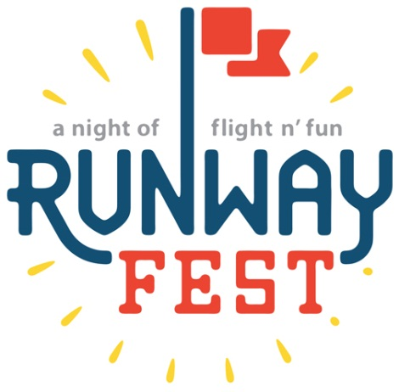

Runway Fest 2018

Dear Potential Sponsor:

Dayton-Wright Brothers Airport is hosting its 7th Annual Runway Fest on August 10, 2018. Runway Fest continues to be an overwhelming success. In 2017 this event was attended by over 3,500 visitors. The festival includes great food, fantastic entertainment and top-notch fireworks. This FREE event encompasses fun for the whole family with a live band, inflatables for the kids, top-notch fireworks, and much more.

Take advantage of this great opportunity to showcase your organization’s involvement with the community. Runway Fest is promoted as a community-wide event and advertisements and articles will be placed in local newspapers. Flyers will be placed throughout the local area in stores and businesses. There will also be publicity through electronic billboards, strategically located banners, participating organization websites, and social media. #RunwayFest2018.

We hope you will be able to join us for this one of a kind community event. For information regarding the sponsorship process, please see the following forms. If you have any questions, please feel free to contact us.

Brandon Ellis (937) 454-8230 BEllis@flydayton.com
Yolanda Sanders (937) 454-8219 YSanders@flydayton.com

Runway Fest 2018 Sponsorship Levels

Platinum Sponsor
$1,500
- Recognition on media news releases
- Name/logo on all printed materials (banners, flyers, etc.)
- Logo on t-shirts
- Large logo on main banner
- Recognition plaque
- Recognition at event via PA announcements
- 8 t-shirts for your staff
- Table for display in the Expo area (no sales)

Gold Sponsor
$1,000
- Recognition on media news releases
- Logo on t-shirts
- Medium logo on main banner
- Recognition plaque
- Recognition at event via PA announcements
- 5 t-shirts for your staff
- Table for display in the Expo area (no sales)

Silver Sponsor
$500
- Logo on t-shirts
- Small logo on main banner
- Recognition plaque
- Recognition at event via PA announcements
- 3 t-shirts for your staff
- Table for display in the Expo area (no sales)

Bronze Sponsor
$250
- Name on t-shirts
- 2 t-shirts for your staff
- Table for display in the Expo area (no sales)
Runway Fest 2018
Sponsorship Response Form

August 10, 2018 at Dayton-Wright Brothers Airport

YES! WE WILL PARTICIPATE AS SPONSOR:

☐ Platinum Sponsor $1,500*
☐ Gold Sponsor $1,000*
☐ Silver Sponsor $500*
☐ Bronze Sponsor $250

☐ In-Kind Sponsor Donation ___________________________________
(Any non-monetary donation such as door prizes, advertising, products, etc.)

Please list your name as you want it to appear in the program:
________________________________________________________________
Type: ☐Organization ☐Group ☐Business ☐Individual
Contact Person: ___________________________________________________
Address: _________________________________________________________
City: _______________________________ State: ________ Zip: ____________
Phone: (_____) ______________________
Email Address: ____________________________________________________

Authorized Signature: _______________________________________________
_____________________________________________________________________
Website, Twitter, Facebook, Instagram, etc.

Please make checks payable to: DACC EPI Foundation for Runway Fest

Please return this form with sponsorship check to:
Yolanda Sanders
Dayton Int’l Airport
3600 Terminal Drive, Ste. 300
Vandalia, OH 45377

*NOTE: Please e-mail a high-resolution file of your company’s logo to ysanders@flydayton.com by July 6, 2018.

